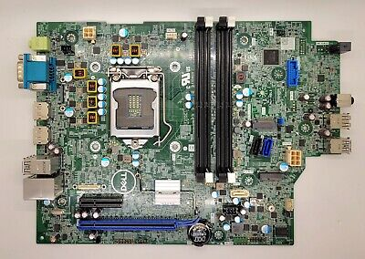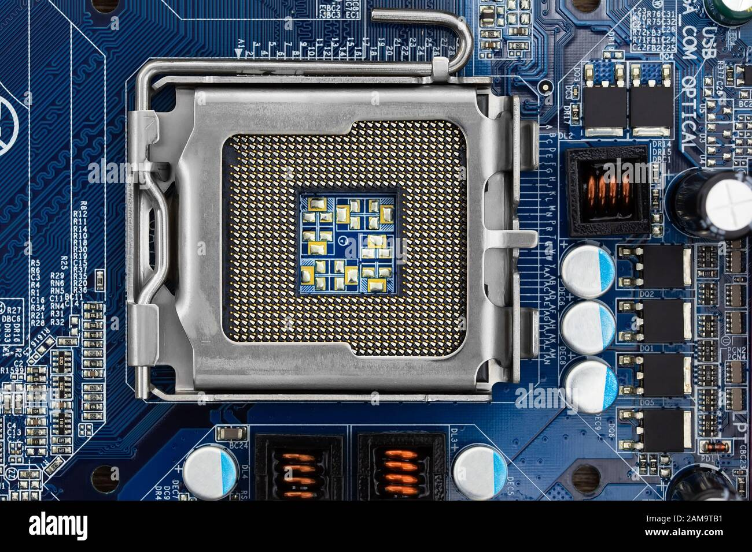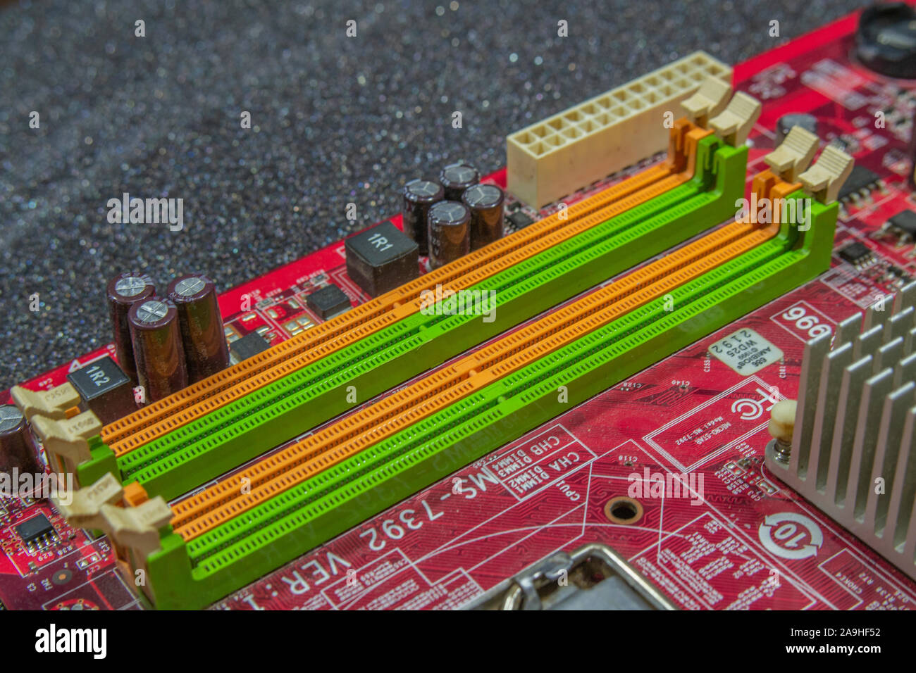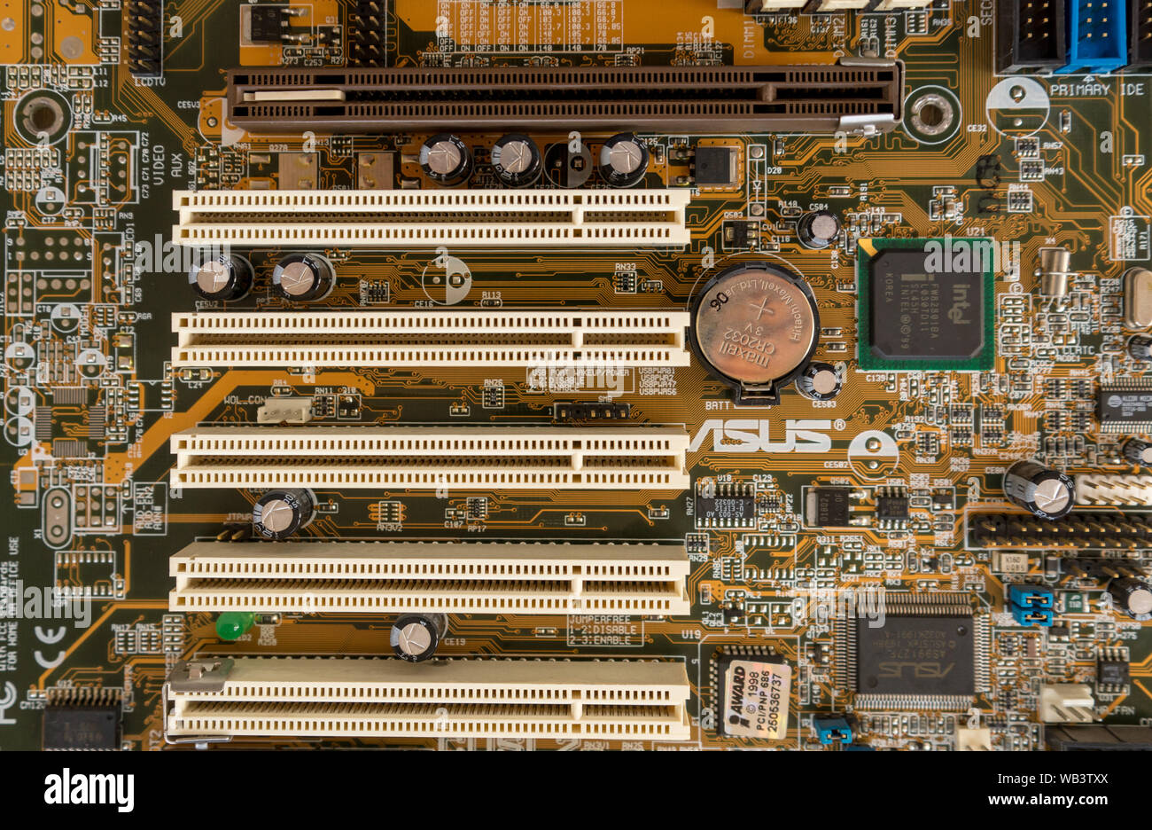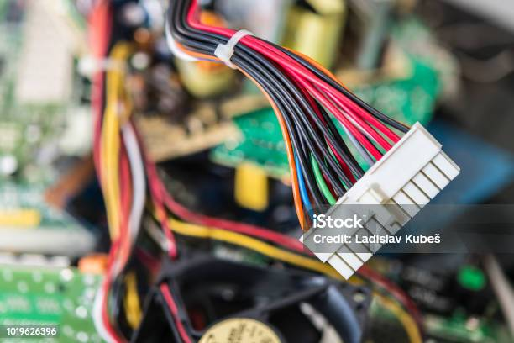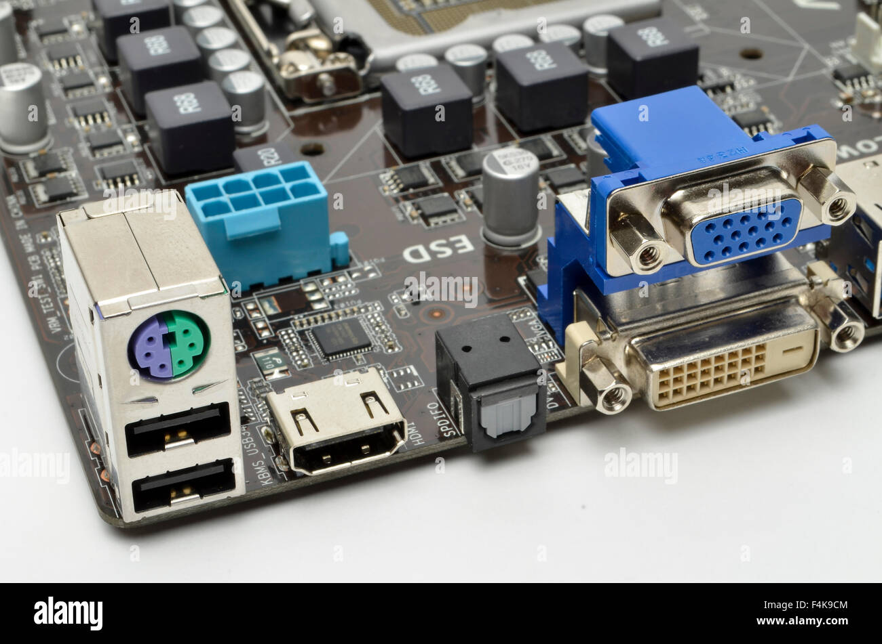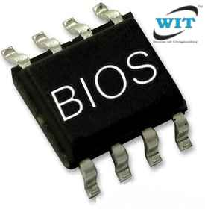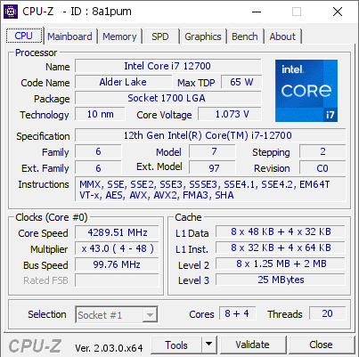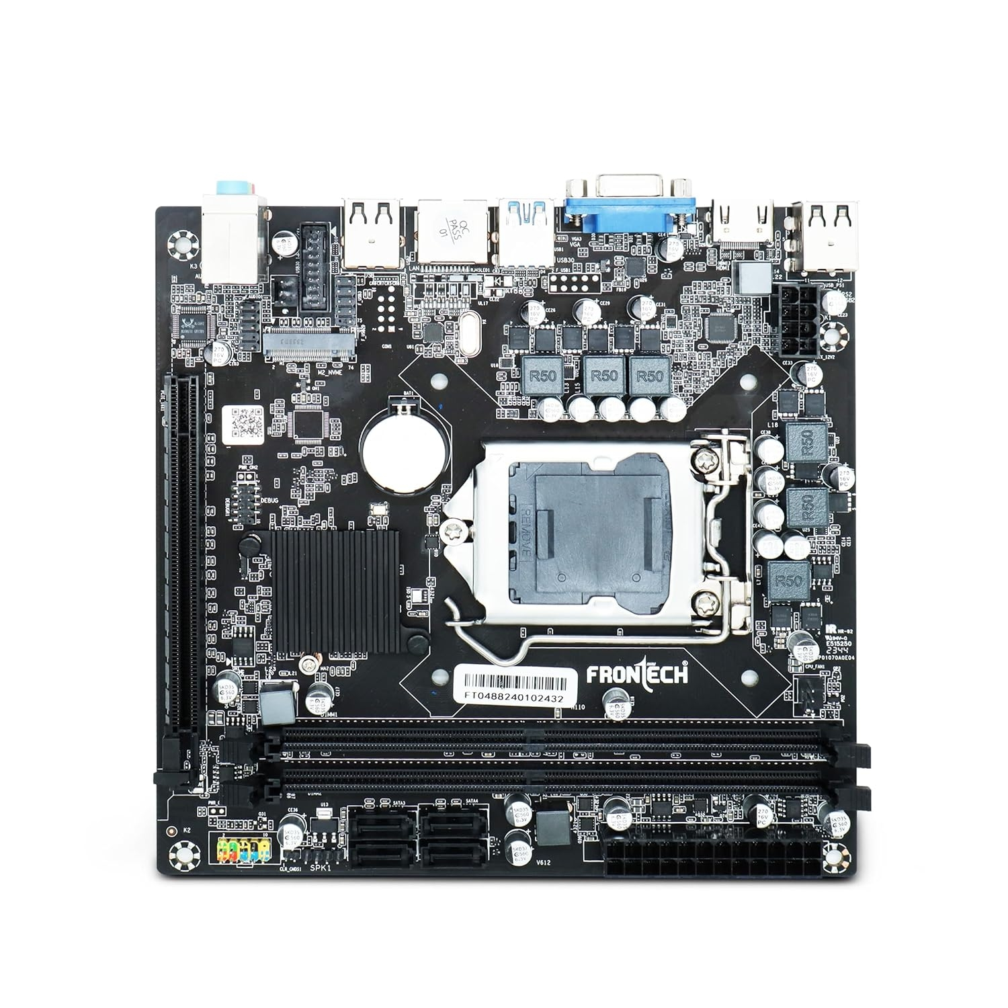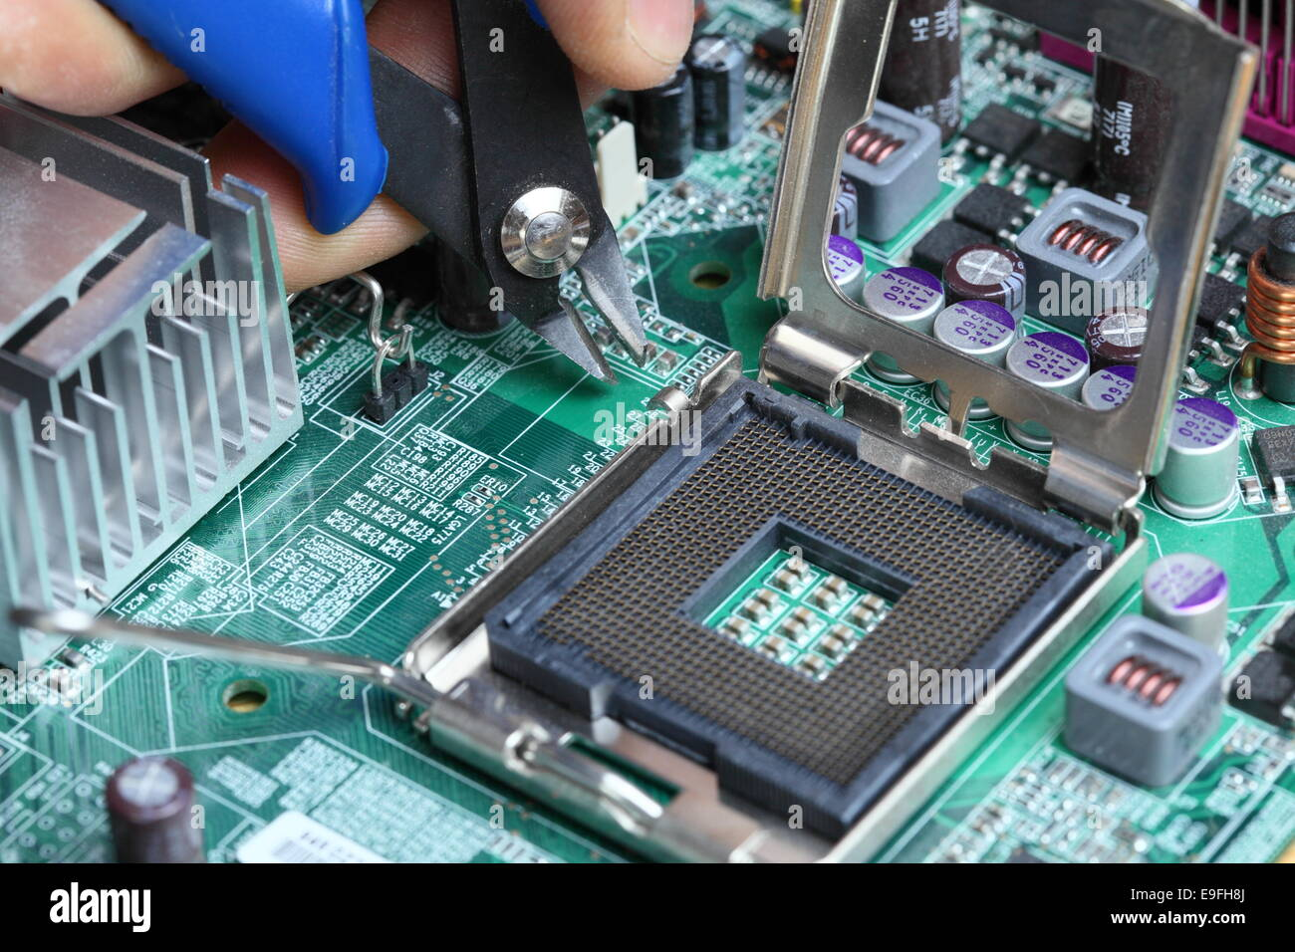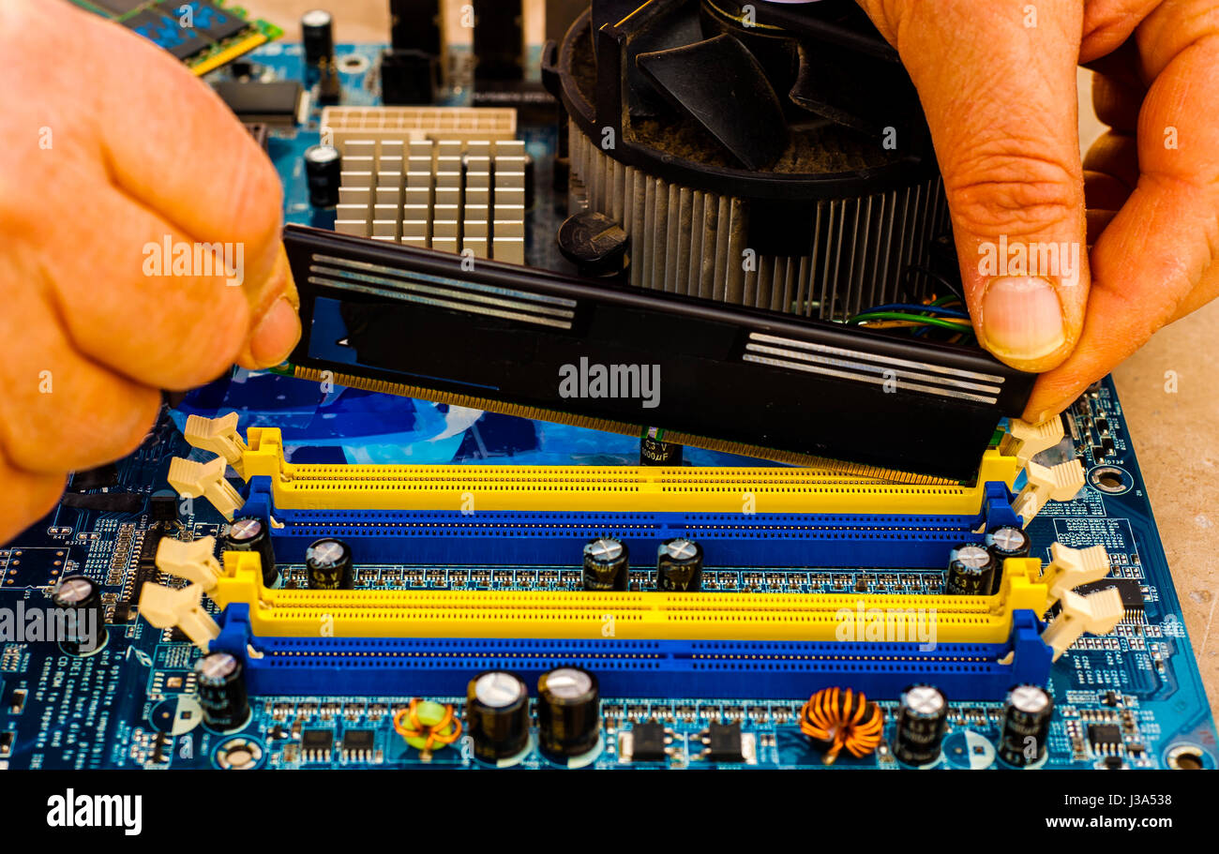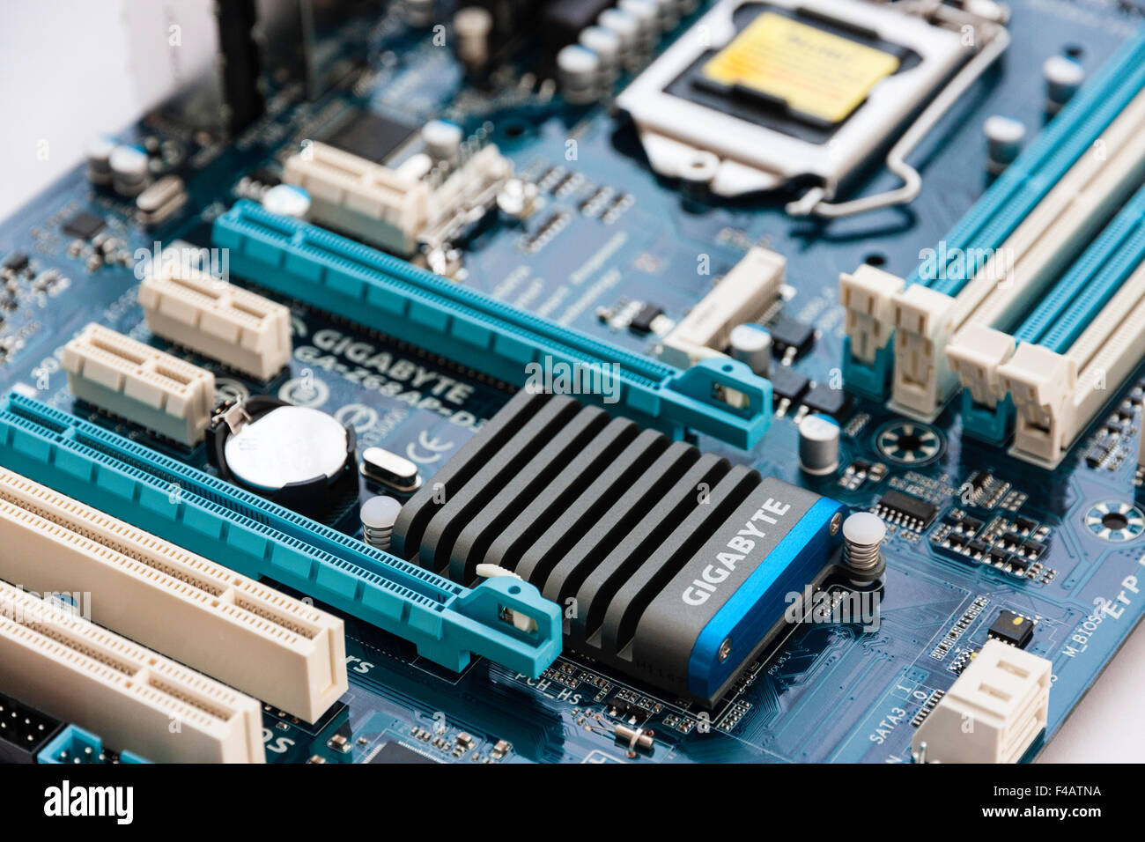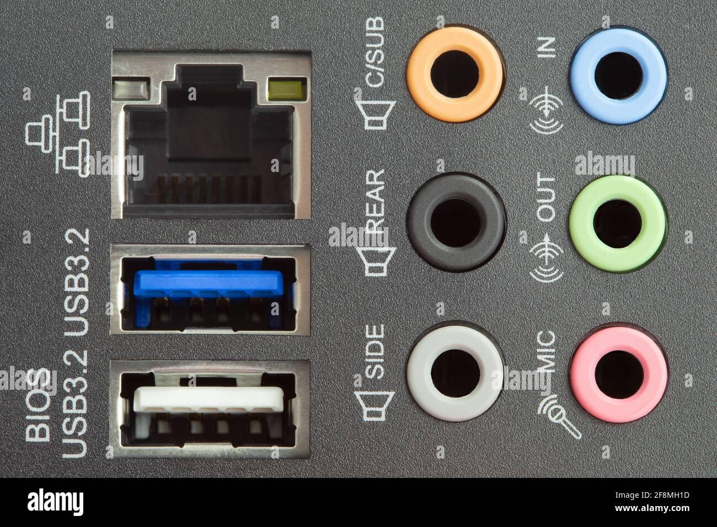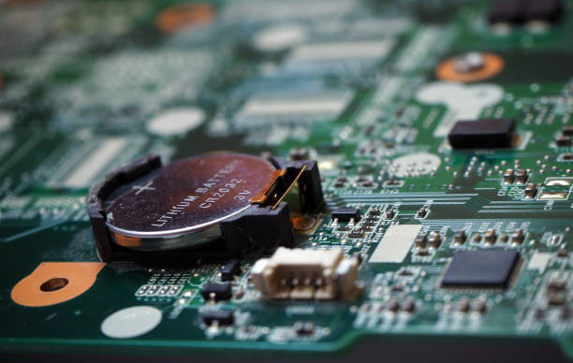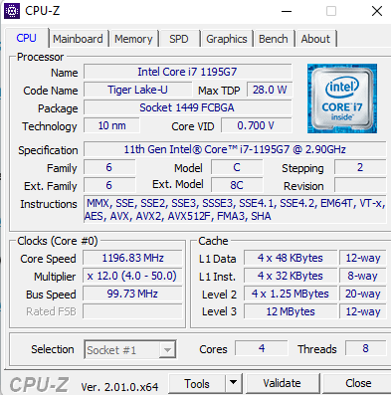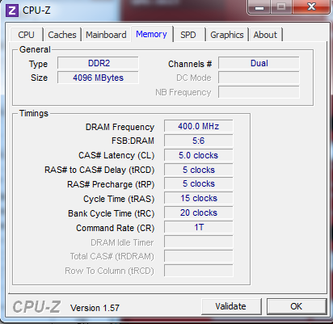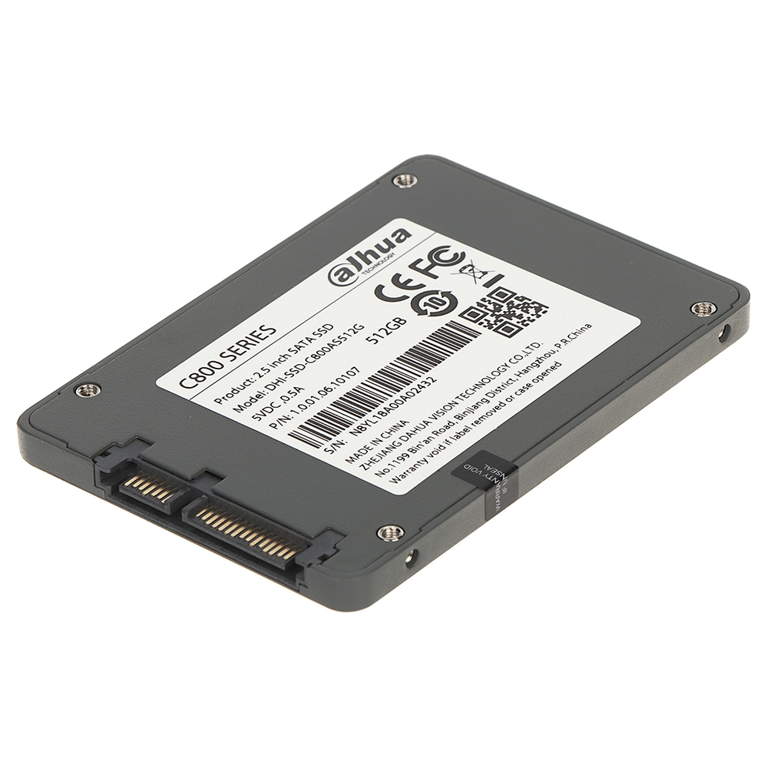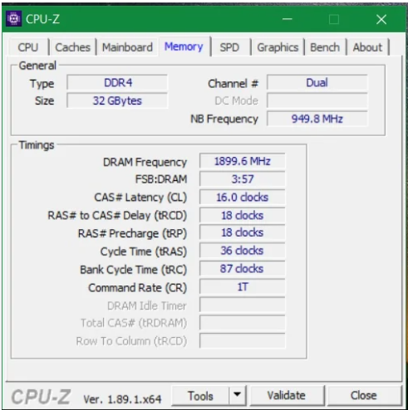

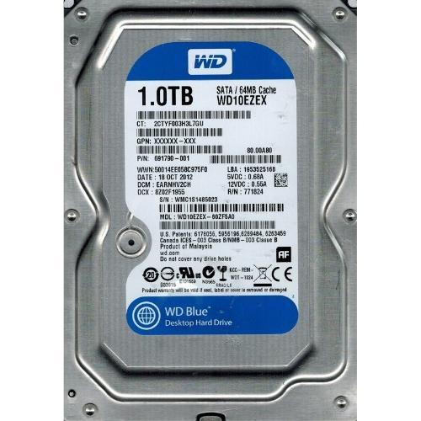

**IUBAT**- *International University of Business Agriculture and Technology*



**Course Name**: COMPUTER HARDWARE AND MAINTENANCE LAB

**Course Code**: CSC 348

**Assignment**

**Submitted To**

Kashfi Shormita Kushal

Lecturer,

Department of Computer Science and Engineering

IUBAT

**Submitted By**

Tonmoy Sarker

ID:22203004

Section: F

SL:12

Program: BCSE



**IUBAT**- *International University of Business Agriculture and Technology*



**Course Name**: COMPUTER HARDWARE AND MAINTENANCE LAB

**Course Code**: CSC 348

**Assignment**

**Submitted To**

Kashfi Shormita Kushal

Lecturer,

Department of Computer Science and Engineering

IUBAT

**Submitted By**

Amit Roy

ID:22303227

Section: E

SL:

Program: BCSE

